

LAB EXPERIMENT RECORD

SET 24

Department | Artificial Intelligence and Data Science
Course Code / Course Name | DSA0601 / Data Handling and Visualization
Name / Register Number | ROHAN P T / 192424112
Date / Day | 15/10/2026

Aim
To analyze product inventory management using the requested visualizations and dashboard views.

Dataset
Product Inventory Management
Product_ID | Product_Name | Quantity_Available | Product_Category | Price
1 | Product A | 250 | Electronics | 20
2 | Product B | 175 | Home | 15
3 | Product C | 300 | Electronics | 18
4 | Product D | 200 | Office | 12
5 | Product E | 220 | Home | 16

R Data Setup
Run this setup once before the R programs below. The dataset is defined inline so each record can be copied and run without a separate CSV file.
R data setup
dat <- data.frame(
Product_ID = c(1, 2, 3, 4, 5),
Product_Name = c("Product A", "Product B", "Product C", "Product D", "Product E"),
Quantity_Available = c(250, 175, 300, 200, 220),
Product_Category = c("Electronics", "Home", "Electronics", "Office", "Home"),
Price = c(20, 15, 18, 12, 16)
)

PROGRAM 1: Quantity by Product
Create a labeled bar chart of quantity available by product.
R code
barplot(dat$Quantity_Available, names.arg=dat$Product_Name, col="skyblue3", xlab="Product", ylab="Quantity", main="Available Quantity by Product")

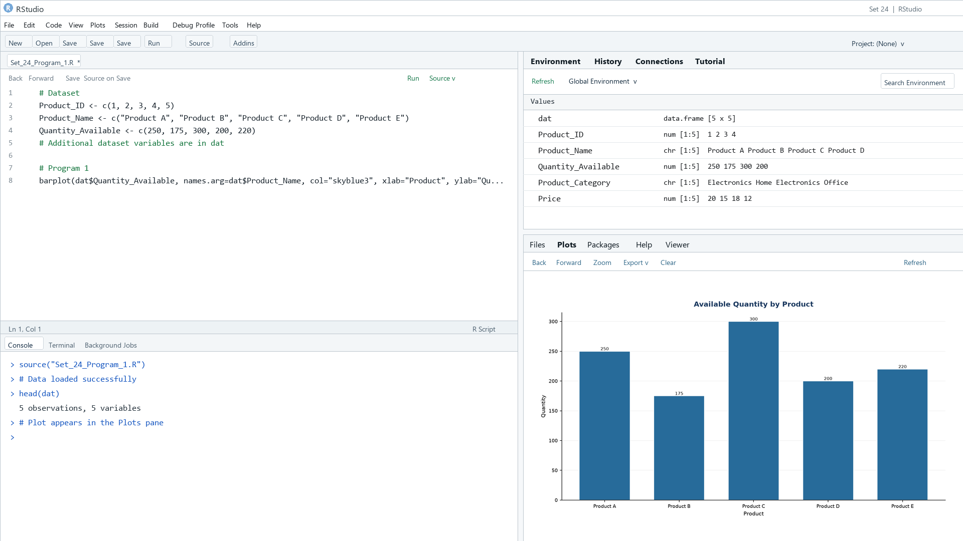
Output 1: Quantity by Product
Observation: Product C has the largest listed quantity (300), while Product B has the smallest (175).

PROGRAM 2: Stacked Quantity by Category
Create a stacked bar chart of product quantities within product categories.
R code
library(ggplot2)
ggplot(dat, aes(x=Product_Category, y=Quantity_Available, fill=Product_Name)) + geom_col() + labs(title="Inventory by Product Category", x="Category", y="Quantity") + theme_minimal()

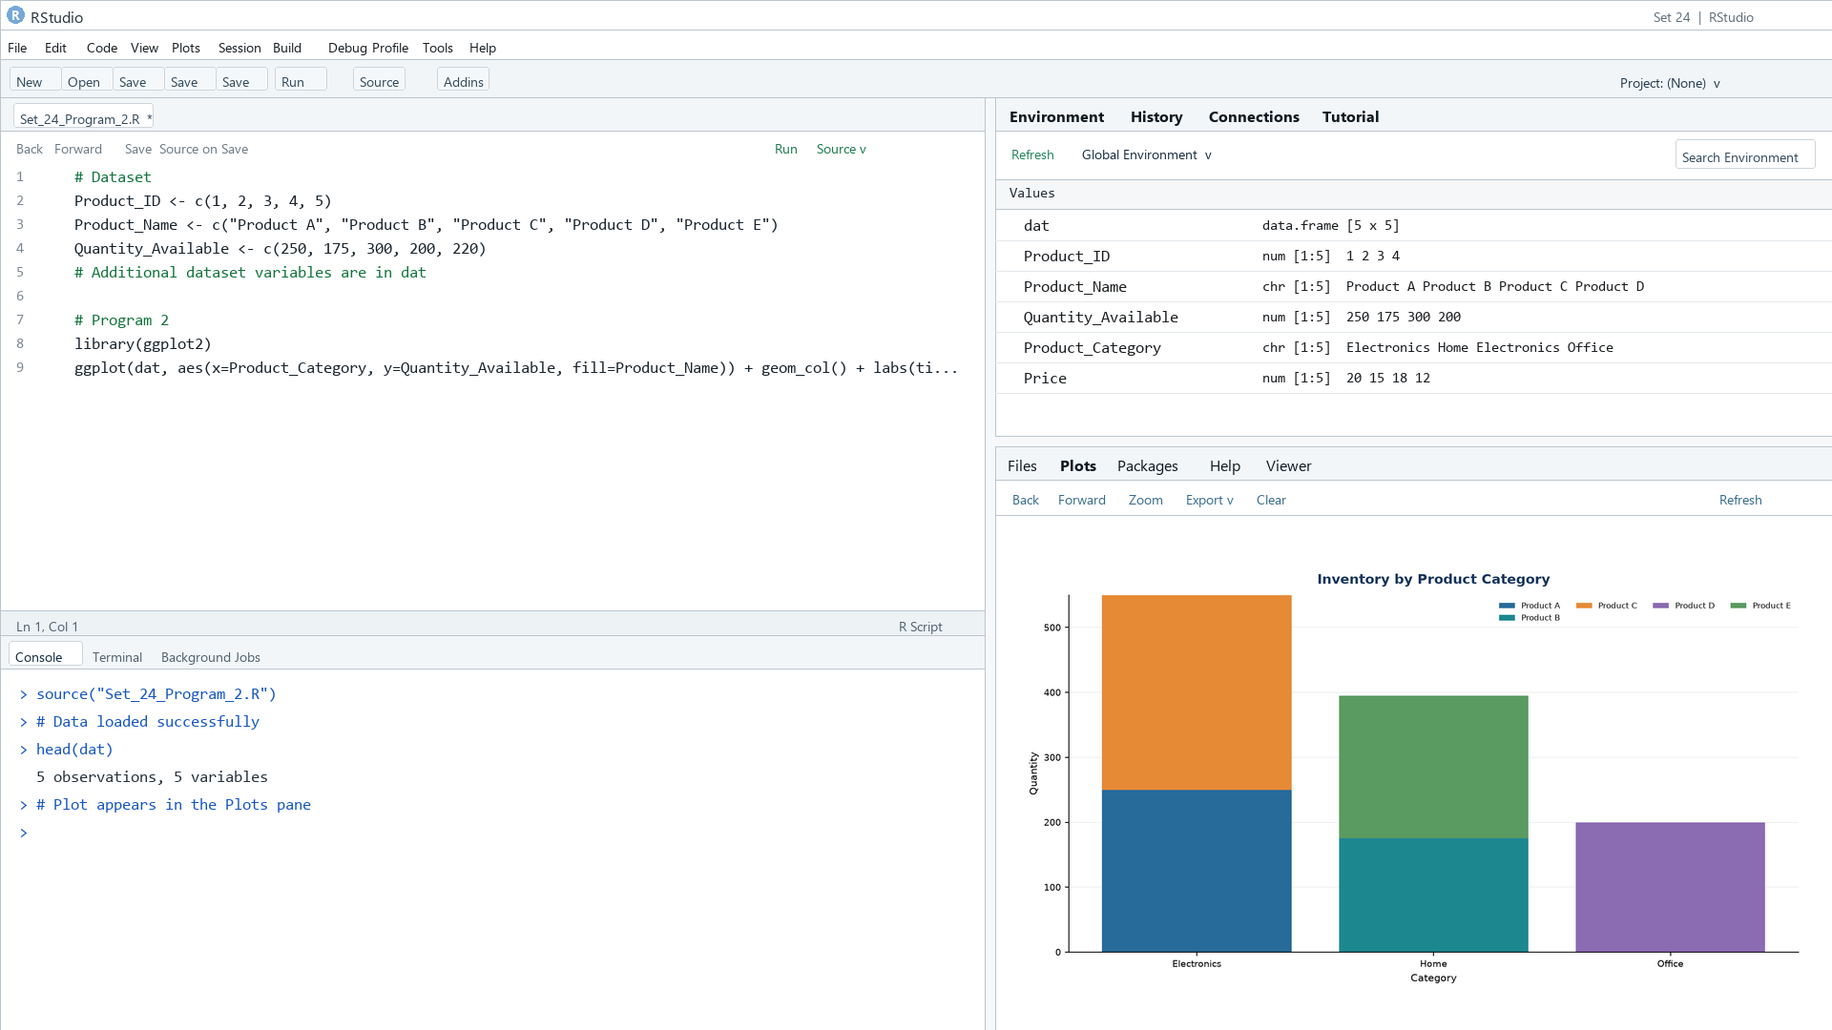
Output 2: Stacked Quantity by Category
Observation: The category chart compares summed available quantities across the illustrative categories.

PROGRAM 3: Product Inventory Dashboard
Build a Tableau dashboard combining the quantity bar chart and category stacked bar chart.
Tableau build steps
Tableau dashboard build
1. Connect to the product inventory table.
2. Create a quantity bar chart by Product_Name.
3. Create a stacked bar chart by Product_Category and Product_Name, using SUM(Quantity_Available).
4. Add both sheets to a dashboard and show a category filter.

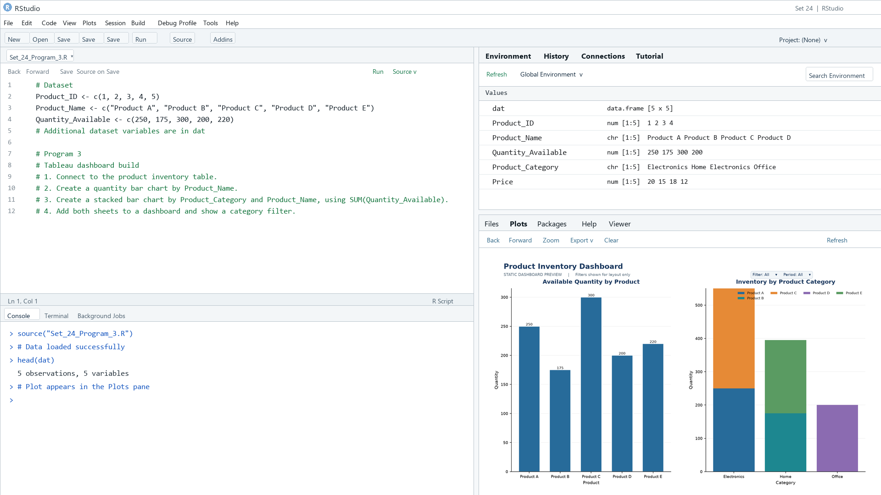
Output 3: Product Inventory Dashboard
Observation: The preview shows the product quantities and category composition side by side.

PROGRAM 4: Price and Quantity Scatter Plot
Create a scatter plot to explore price versus quantity and explain the result.
R code
plot(dat$Price, dat$Quantity_Available, pch=19, col="#276B9A", xlab="Price ($)", ylab="Quantity available", main="Product Price vs Quantity")

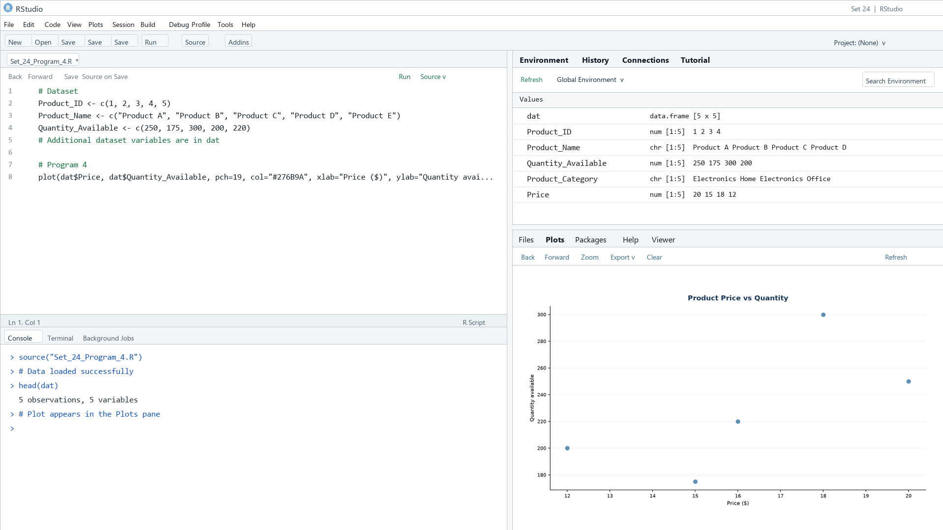
Output 4: Price and Quantity Scatter Plot
Observation: The illustrative points show no clear monotonic relationship between price and quantity.

Procedure
1. Review the dataset table and confirm any illustrative fields noted in the record.
2. Run the R setup block once, then run the requested program code.
3. Compare the output screenshot with the observation and replace illustrative values when actual data is available.
4. For Tableau tasks, connect to the displayed data and follow the dashboard build steps.

Result
The requested charts and dashboard views for Set 24 were prepared from the displayed dataset. Outputs include labels, short observations, and code or dashboard construction steps.

Key Functions Used
plot(), barplot(), hist(), boxplot(), table().

